Minor Project (BTCS607N) Weekly Progress Report (Week-2)
Project Title: Vaari - Crop Water Footprint Information App
Phase 1 — Planning & Requirement Analysis
Goal: Identify actors, define the system boundary, and prepare the use case model for the Vaari application.
1. Introduction
- Week 2 focuses on functional modeling of the Vaari application.
- The purpose of this week is to identify the users of the system and define how each user will interact with the application.
- This helps convert the project idea into clear system actions that can be designed and implemented later.
2. Actors Identification
- Administrator: responsible for managing crop data.
- General User: searches crops, views water footprint, and changes language.
3. Use Case Diagram
- The use case diagram shows the interaction between the actors and the Vaari system.
- It includes the main functions of the application such as crop search, water footprint viewing, search history, and language change.
- The diagram also shows that viewing water footprint is included as part of the crop search flow.

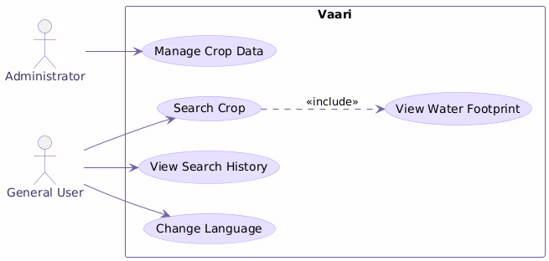

4. Use Case Description
- Search Crop: The user enters a crop name and receives matching crop details.
- View Water Footprint: The application shows green, blue, and grey water values for the selected crop.
- View Search History: The user can check previously searched crops.
- Change Language: The user can switch the app language for better readability.
- Manage Crop Data: The administrator can update or maintain crop-related information.
5. Scope of Week 2
- Week 2 is limited to requirement modeling and use case preparation.
- No coding or database implementation is done in this week.
- This week establishes the base for later class, activity, and sequence diagrams.
6. Deliverables
- Identified actors.
- Use case diagram.
- Use case descriptions.
- Mapped functional interactions for Vaari.
7. Expected Outcome
- A clear functional view of the system.
- Proper understanding of user roles and their interactions.
- A strong foundation for static and dynamic analysis in the next week.
8. Team Roles
- Team members will collaborate on diagram preparation and documentation.
- The work will be divided between analysis, design, and report writing tasks.

Mentor Signature ___________________ Project Guide Signature _____________________

